

KTO KARATAY UNIVERSITY

ENGINEERING FACULTY

COMPUTER ENGINEERING DEPARTMENT

2021-2022 FALL SEMESTER

CE 341 DATABASE MANAGEMENT SYSTEMS

TERM PROJECT

COOPERATIVE HOUSING PROJECT DATABASE

21934249 – Dirruba TUNÇEZ

Requested = Database of a cooperative housing project

* In the cooperative housing database project I designed; the id, name, surname, telephone, e-mail, address, province, and district information of the members who entered the cooperative from scratch and became a tenant after the project is completed are kept in the member table.
* In the payments table; before the start of the project, the of all members payment ID, the amount of advance deposited, the installment fees paid until the end of the project, the first and last payment dates of the last payment.

The amount of penalty to be paid by the members who delay the payment date and member identification information are stored.

* In the expense table, each member's expense ID, member ID, if a tenant, tenant ID, electricity, water, natural gas, fuel, dues information will be kept.
* In the tenant table, the members who are tenants; tenant ID, name, surname, phone, email address, lease ID information is kept.
* In the lease table of the members renting the house; lease ID, member ID, rent money, amount of deposit paid, rental start date, rental end date, tenant's delay penalty, square meters of the rented house, and the door number of the lease house are kept.
* In the visitor information table, the visitor's ID, name, surname, phone number, date of arrival, date of departure, the ID of the member she came from, and the door number of the member she came from are kept.
* In the apartment information table, the apartment ID, the name of the apartment, the address of the apartment, the number of floors, and the information of which apartment is how many are kept.
* In the meetings table, meeting ID, the meeting date, the decisions taken at the meeting, and the ID information of the member who is the manager among the members are kept.
* In the house information table, house id, door number, number of rooms, square meters, rent if rent money, member id, and apartment name information are kept.

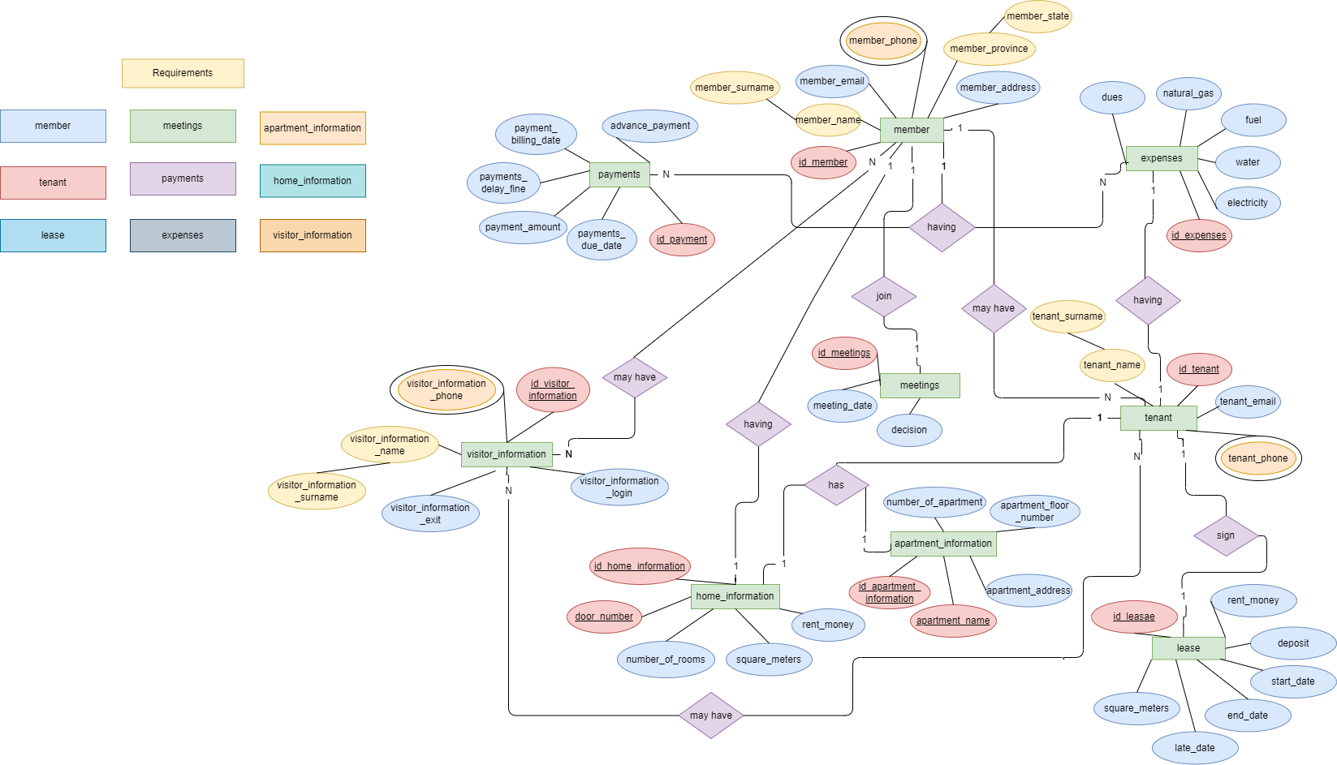

* Each member's member ID, member name, member surname, member phone, member e-mail, members home address at registration(member address), member province and member state registration date will be arrested in the system.
* Each tenant's tenant ID, tenant name, tenant surname, tenant phone, tenant e-mail, and lease ID will be arrested in the system.
* Each tenant’s(also the member's) lease ID, rent money, deposit, lease payment date (start date), payment due date, rental late fee(late fee), a square meter of the house (square meters), member ID and door number will be arrested in the system.
* Each meetings meeting ID, meeting date, decisions are taken at the meeting (decision), and ID of the site manager(ID member manager) will be arrested in the system.
* Each member’s payments ID, the amount of advance payment paid when entering the cooperative (payment amount), payment billing date, payment due date, payments delay fine and member ID will be arrested in the system.
* Each member’s expenses ID, electricity, water, fuel, natural gas, dues, member ID, and tenant ID will be arrested in the system.
* Each apartment apartment ID, apartment name, apartment address, apartment floor number, and a number of apartments will be arrested in the system.
* Each home home ID, door number, number of rooms (…+…), a square meter of the house (square meters), rent money, member ID, and apartment name will be arrested in the system.
* Each visitor visitor ID, visitor name, visitor surname, visitor phone, the date the visitor arrived (visitor login), the date the visitor went (visitor exit), information on which house the visitor came to and information on which member the visitor came to (member ID) will be arrested in the system.

**2)**

* Each member can have more than one payment.
* Each member can only have one expense.
* Each member can have more than one guest and, each guest can go to more than one member.
* Only one member can be an administrator at each meeting.
* Each member can only have one house information.
* Each member can have more than one tenant.
* Any tenant can only have one home information.
* Any tenant can only have one apartment information.
* Each tenant can have more than one guest and, each guest can go to more than one tenant.
* Any tenant can have only one rental information.

**3)**

**PRİMARY KEY:**

**MEMBER TABLE:** id_member,(primary key, NOT NULL, unique)

**PAYMENTS TABLE:** id_payments, (primary key, NOT NULL, unique)

**EXPENSES TABLE:** id_expenses, (primary key, NOT NULL, unique)

**VISITOR_INFORMATION TABLE:** id_visitor_information, (primary key, NOT NULL, unique)

**APARTMENT_INFORMATION TABLE:** id_apartment_information, (primary key, NOT NULL, unique), apartment_name, (primary key, NOT NULL, unique)

**HOME_INFORMATION:** id_home_information, (primary key, NOT NULL, unique), door_number, (primary key, NOT NULL, unique)

**MEETING TABLE:** id_meetings, (primary key, NOT NULL, unique)

**LEASE TABLE:** id_lease, (primary key, NOT NULL, unique)

**TENANT TABLE:** id_tenant. (primary key, NOT NULL, unique)

**FOREIGN KEY:**

**PAYMENTS TABLE:** FK_member_id, (NOT NULL) (CASCADE)

**EXPENSES TABLE:** FK_member_id_(NOT NULL) (CASCADE), FK_id_tenant,(NULL) (CASCADE)

**VISITOR_INFORMATION TABLE:** FK_id_membeer_ (NOT NULL) (CASCADE), FK_door_numbeer_ (NOT NULL), (CASCADE)

**HOME_INFORMATION:** FK_iid_member (NOT NULL) (CASCADE), FK_apartment_name (NOT NULL) (CASCADE),

**MEETING TABLE:** FK_id_member_manager (NOT NULL) (CASCADE),

**LEASE TABLE:** FK_id_member (NOT NULL) (CASCADE), FK_door_number (NOT NULL) (CASCADE),

**TENANT TABLE:** FK_iid_lease (NOT NULL) (CASCADE).

**Payments Table**

* id_payment,(primary key, NOT NULL, unique),
* payments_amount (NULL),
* advance_payment(NULL),
* payment_billing_date (NOT NULL),
* payment_due_date (NOT NULL),
* payments_delay_fine(NULL),
* FK_member_id (NOT NULL).

**Member Table**

* id_member,(primary key, NOT NULL, unique),
* member_name(NOT NULL),
* member_surname_(NOT NULL),
* member_phone(NOT NULL, unique),
* member_email, (NOT NULL, unique)
* member_address(NOT NULL),
* member_province(NOT NULL),
* member_state(NOT NULL).

**Expenses Table**

* id_expenses(primary key, NOT NULL, unique),
* electricity(NULL),
* water(NULL),
* fue(NOT NULL),
* natural_gas(NULL),
* dues(NOT NULL),
* FK_member_id_(NOT NULL),
* FK_id_tenant (NULL).

**Tenant Table**

* id_tenant (primary key, NOT NULL, unique),
* tenant_name(NOT NULL),
* tenant_surname(NOT NULL),
* tenant_email(NOT NULL, unique),
* tenant_phone(NOT NULL, unique)
* FK_iid_lease(NOT NULL)

**Visitor_information Table**

* id_visitor_information(primary key, NOT NULL, unique),
* visitor_information_login(NOT NULL),
* visitor_information_exit(NOT NULL),
* visitor_information_name(NOT NULL),
* visitor_information_surname(NOT NULL),
* visitor_information_phone(NOT NULL),
* FK_id_membeer_ (NOT NULL),
* FK_door_numbeer_(NOT NULL).

**Home_information Table**

* id_home_information(primary key, NOT NULL, unique),
* door_number (primary key, NOT NULLL, unique),
* number_of_rooms(NOT NULL),
* square_meters(NOT NULL),
* rent_money (NULL),
* FK_iid_member(NOT NULL),
* FK_apartment_name (NOT NULL),

**Apartment_information Table**

* id_apartment_information(primary key, NOT NULL, unique),
* apartment_name (primary key, NOT NULL, unique),
* apartment_address(NOT NULL),
* apartment_floor_number(NOT NULL),
* number_of_apartment(NOT NULL).

**Lease Table**

* id_lease(primary key, NOT NULL, unique),
* rent_money (NOT NULL),
* deposit (NULL),
* start_date(NOT NULL),
* end_date(NOT NULL),
* late_date(NOT NULL),
* square_meters (NOT NULL),
* FK_id_member (NOT NULL),
* FK_door_number (NOT NULL).

**Meetings Table**

* id_meetings (primary key, NOT NULL, unique),
* meeting_date_ (NOT NULL),
* decision (NULL),
* FK_id_member_manager (NOT NULL).

**SCHEMATİC VİEW OF FOREİGN KEY AND PRİMARY KEYS**

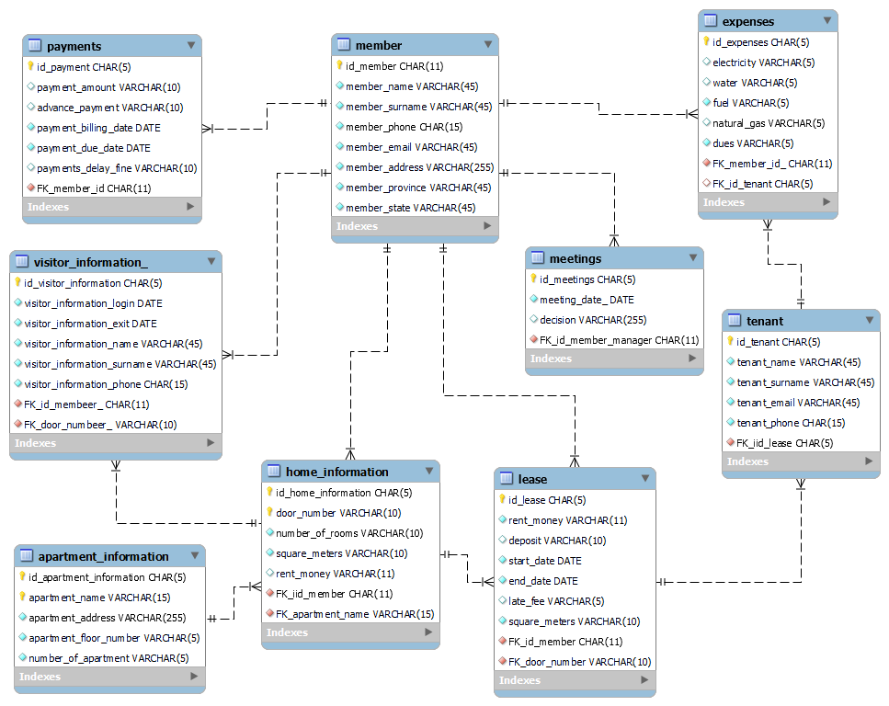

**5)**

**ENTITY-RELATİONSHIP DIAGRAM**

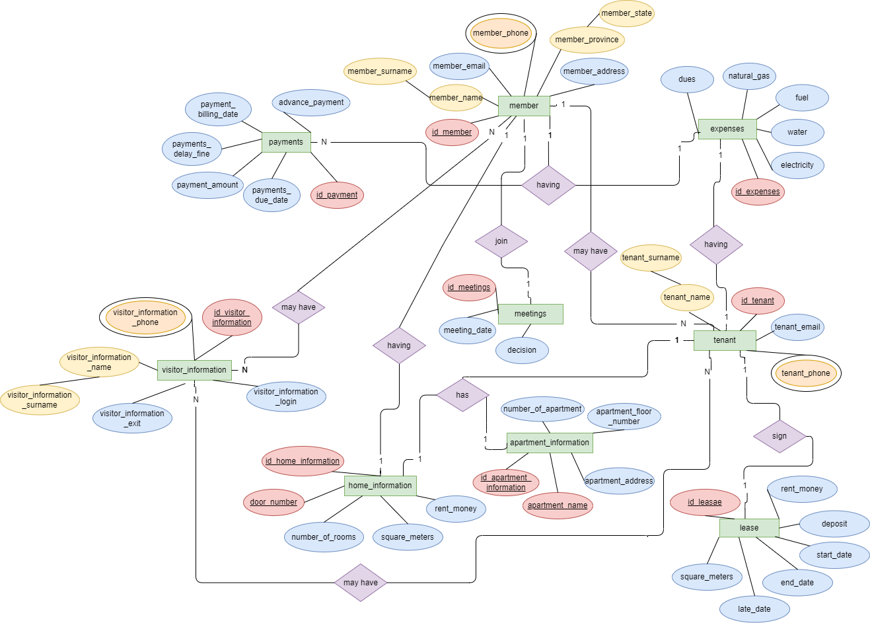

**6)**

**RELATİONAL – SCHEMA**

**payments**

|  |  |  |  |  |  |
| --- | --- | --- | --- | --- | --- |
| id_payments | payment  _amount | advance  _payment | payment  _billing_date | payment  _due_date | payments_  delay_fine |



**member**



|  |  |  |  |  |  |  |  |  |  |  |
| --- | --- | --- | --- | --- | --- | --- | --- | --- | --- | --- |
| İd_  member | Mem  Ber  _name | Mem  ber_sur  name | Mem  ber_  phone | Mem  Ber  _email | Mem  ber_  add  ress | Mem  Ber  _prov  ince | Mem  ber  _state | İd_  Pay  ments | İd_  Ex  Pen  ses | İd_  tenant |



**expenses**



|  |  |  |  |  |  |
| --- | --- | --- | --- | --- | --- |
| İd_expenses | electricity | water | fuel | Natural_gas | dues |

**tenant**



|  |  |  |  |  |
| --- | --- | --- | --- | --- |
| İd_tenant | Tenant_name | Tenant_surname | Tenant_email | Tenant_phone |



**Visitor_informaation**



|  |  |  |  |  |  |  |  |
| --- | --- | --- | --- | --- | --- | --- | --- |
| İd_visitor  _infor  mation | Visitor_  İnfor  mation  _login | Visitor_  İnfor  mation  _exit | Visitor_  İnfor  mation  _name | Visitor_  İnfor  mation  _surname | Visitor_  İnfor  mation  _phone | İd_  member | İd_  tenant |



**Home_information**

|  |  |  |  |  |
| --- | --- | --- | --- | --- |
| İd_home_information | Door_number | Number_of_rooms | Square_meters | Rent_money |



**Apartment_information**

|  |  |  |  |  |
| --- | --- | --- | --- | --- |
| İd_apartment_information | Apartment_  name | Apartment_  address | Apartment_  floor | Number_of_  apartment |



**lease**

|  |  |  |  |  |  |  |
| --- | --- | --- | --- | --- | --- | --- |
| İd_lease | Rent_money | deposit | Start_date | End_date | Late_fee | Square_meters |



|  |  |  |
| --- | --- | --- |
| İd_meetings | Meeting_date_ | decision |

**meetings**

**Payments =** id_payment, payments_amount, advance_payment, payment_billing_date, payment_due_datei, payments_delay_fine

**Member =** id_member, member_name, member_surname_ member_phone, member_email, member_address, member_province, member_state

**Expenses =** id_expenses, electricity, water, fuel, natural_gas, dues

**Tenant =** id_tenant, tenant_name, tenant_surname, tenant_email, tenant_phone

**Visitor_information =** id_visitor_information, visitor_information_login, visitor_information_exit, visitor_information_name, visitor_information_surname, visitor_information_phone

**Home_information =** id_home_information, door_number, number_of_rooms, square_meters, rent_money

**Apartment_information =** id_apartment_information, apartment_name, apartment_address, apartment_floor_number, number_of_apartment

**Lease =** id_lease, rent_money, deposit, start_date, end_date, late_date, square_meters

**Meetings =** id_meetings, meeting_date_, decision